Chapter 14, Problem 43.

Calculate the resonant frequency of each of the circuits in Fig. 14.82.
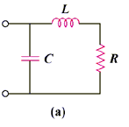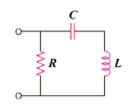

(b)

Figure 14.82
For Prob. 14.43.

